**HTML valign Attribute**

Last Updated : 30 Jan, 2024

The **HTML valign**attributeis used to specify the vertical alignment of the text in the element. This attribute supports many table-related elements such as [<tr>](https://www.geeksforgeeks.org/html-tr-tag/),[<td>](https://www.geeksforgeeks.org/html-td-tag/" \t "_blank),[<tbody>](https://www.geeksforgeeks.org/html-tbody-tag/),[<col>](https://www.geeksforgeeks.org/html-col-tag/), and [<tfoot>.](https://www.geeksforgeeks.org/html-tfoot-tag/)

**Note:**The valign attribute is not supported by [HTML5](https://www.geeksforgeeks.org/html5).

**Syntax:**

<element valign="top | middle | bottom | baseline">

**Attribute value:**

| **Attribute Value** | **Description** |
| --- | --- |
| top | Sets the content to top-align. |
| middle | Sets the content to middle-align. |
| bottom | Sets the content to bottom-align. |
| baseline | Sets the content to baseline-align. The baseline is the line where most of the characters sit in the table data element. |

**Example:**This example illustrates the use of *valign*attribute in the HTML document.

* HTML

|  |
| --- |
| <!DOCTYPE html>  <html>    <head>      <title>          HTML valign Attribute in <td> element      </title>  </head>    <body>      <h1>GeeksforGeeks</h1>        <h2>HTML valign Attribute in Table Data Element</h2>        <table border="1" width="500">          <tr>              <th>NAME</th>              <th>ID</th>              <th>AGE</th>          </tr>            <tr style="height:50px;">              <td valign="top">BITTU</td>              <td valign="center">123</td>              <td valign="bottom">21</td>          </tr>            <tr style="height:50px;">              <td valign="bottom">RAKESH</td>              <td valign="center">124</td>              <td valign="top">24</td>          </tr>      </table>  </body>    </html> |

**Output:**

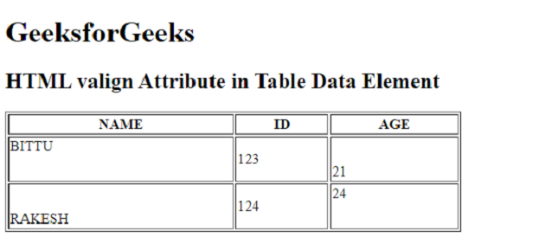

**Supported Browsers:**

* Google Chrome 1
* Edge 12
* Firefox 1
* Safari 4
* Opera 1

Comment

More info

[Advertise with us](https://www.geeksforgeeks.org/about/contact-us/?listicles)

[**Next Article**](https://www.geeksforgeeks.org/html-value-attribute/?ref=next_article)

[HTML | value Attribute](https://www.geeksforgeeks.org/html-value-attribute/?ref=next_article)

**Similar Reads**

**[HTML valign Attribute](https://www.geeksforgeeks.org/html-valign-attribute/?ref=ml_lbp)**

[The HTML valign attribute is used to specify the vertical alignment of the text in the element. This attribute supports many table-related elements such as <tr>,<td>,<tbody>,<col>, and <tfoot>.  Note: The valign attribute is not supported by HTML5. Syntax:<element va](https://www.geeksforgeeks.org/html-valign-attribute/?ref=ml_lbp)

[1 min read](https://www.geeksforgeeks.org/html-valign-attribute/?ref=ml_lbp)

**[HTML | value Attribute](https://www.geeksforgeeks.org/html-value-attribute/?ref=ml_lbp)**

[The value attribute in HTML is used to specify the value of the element with which it is used. It has different meaning for different HTML elements. Usage: It can be used with the following elements: <input>, <button>, <meter>, <li>, <option>, <progress>, and <](https://www.geeksforgeeks.org/html-value-attribute/?ref=ml_lbp)

[3 min read](https://www.geeksforgeeks.org/html-value-attribute/?ref=ml_lbp)

**[HTML | span Attribute](https://www.geeksforgeeks.org/html-span-attribute/?ref=ml_lbp)**